QWANQWA: Traditional Ethiopian Groove with a Modern Twist

QWANQWA is a supergroup of musicians from the baddest ensembles of Addis Ababa. Brought together by a shared passion for the power of Ethiopian music, this quintet shines an experimentalism based in the virtuosity of rooted traditions. With swirling mesenko (one-stringed fiddle), punk krar (six-stringed lyre) solos, wah-wah-violin, bass krar boom, and the unstoppable rhythm of heavy kebero (goat-skin drum) beats, Qwanqwa keeps the people wrapped in celebratory attention. After making a splash at world renowned festivals Roskilde and WOMEX, this world traveling ensemble is hitting the road in 2018 and beyond.
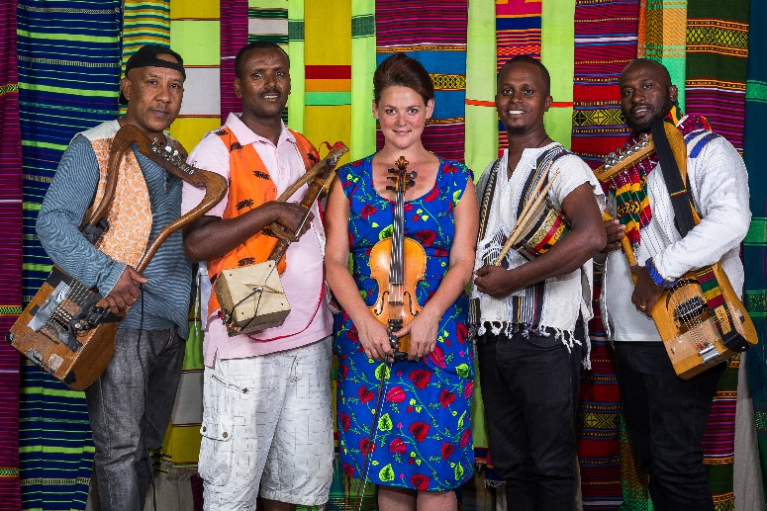
Vemund Brune-Hareide
QWANQWA draws inspiration from East Africa regions of Ethiopia and beyond. Delving deep into regional beats and moods, the repertoire ranges from a trance-like song of the Eritrean tribe of Blen to a Somalian rock number to Mahmoud Ahmed sing-a-longs. The music is characterized by tight arrangements and extended experimental moments. The live show ranges from intimate to wild, from whispery conversations to full blown rock show, and it is hard to believe these psychedelic sounds are coming from traditional harp and violin. It is driving, powerful, and different than anything else coming out of Ethiopia at this current Golden Age of Ethiopian music.
The ensemble was founded in 2012 by American violinist Kaethe Hostetter, who first worked in Ethiopian music as a founding member of critically acclaimed Debo Band. Since relocating to Addis in 2009, she has participated in numerous exploratory and professional projects, as she honed her sound and immersed herself further into the culture of her surroundings. In this sense, QWANQWA, the Amharic word for "language," is a project creating dialogues between cultures.
Members of QWANQWA are Endris Hassan (mesenko), Mesele Asmamaw (krar), Kaethe (violin), Bubu Teklemariam (bass krar), and Misale Leggesse (kebero). They have appeared internationally with Getachew Mekuria, The EX, Thurston Moore, Fred Frith, Butch Morris, Debo Band, Nile Project, Fendika, Mahmoud Ahmed, Mulatu Astatke, Addis Acoustic, Ethiocolor, Atse Teodros, Mohammed “Jimmy” Mohammed, and Imperial Tiger Orchestra, and have played stages from Lincoln Center to Bonnaroo, Jazzfest (New Orleans), Moers Festival, Roskilde, WOMEX, WOMAD and more.
An integral and constant presence in Addis Ababa nightlife scene, QWANQWA has been featured performance at Roskilde 2016 (Northern Europe’s biggest music festival). Since their founding in 2012, QWANQWA have released two albums: Volume One (2014) and Volume Two (2015). Their third album, Volume Three, produced by Shahzad Ismaily, is set for 2018 on FPE Records.

